If you would like to be part of a rehearsed reading (you have scripts in front of you at the performance but you will have to attend a few rehearsals, take direction and dress up nice on the night) of William Shakespeare's Star Wars (which is just what it sounds like) then please come to a first read through at Jamie's house (121 East Street, Bega) at one pm on Sunday, November 8. We're planning to do the show mid-December. Let Jamie know if you're coming at feasiblejerome@gmail.com. Intergalactic adventure with rhyming couplets! Mayeth the Force be with us! And right before the new movie comes out … cue the heavy breathing and light sabres!
Do you feel powerful stirrings? Are you feeling dramatically inspired or inspirationally dramatic? Are you a Tony or a Malcolm? (Actually, scratch that: we're probably looking for more of) A Bernie or a Hillary? More to the point: have you ever thought about acting in/directing /producing /lighting/making music for/writing/suggesting/going to see (surely, you're getting the point by now, cause I could go on but this is only a two page newsletter [not including the summer supplement: What Play Will You Look Good In/At This Summer?]) a play? Then come to the THEATRE ONSET ANNUAL GENERAL MEETING on Wednesday, November 18, 6.30pm at 121 East Street, Bega. All are welcome in the light! Don't just sit there STAGE SOMETHING!
MAHAMATI NEEDS YOU TO BE (in)
[THE]
GOD OF CARNAGE
We're staging this brilliant and savage comedy next year and we need one more guy and one more gal who can play mid-30s-40s. Wanna bicker about what's PC and what isn't, who should pay for which kid's dental work and whether we can ever be truly civil? Contact M on the email address above. This'll be wicked fun. We put it to an audience in May, with rehearsals starting this year. Let's do this French play by Yasmina Reza (made into a movie by Roman Polanski with Jodie Foster, Kate Winslet, John C. Reilly and Christoph Waltz) right.

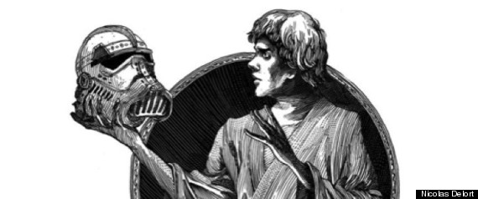
5 MINUTE CALL
the theatre onset newsletter October/November 2015
mahamati@internode.on.net theatreonset.com.au like us on Facebook!
“Know your lines and don't bump into the furniture” - Spencer Tracy

I
WILLIAM SHAKESPEARE'S STAR WARS

REGIONAL ARTS NSW SAYS
A play about alternative political systems and performed at the 18th Norfolk Island Theatre Festival earlier this month has earned its writer, performers and director accolades from audiences and the festival adjudicator, Barbara Lowing. The four are from the south east NSW town of Candelo and surrounds. Faceless, by Mike Martin, and directed by David Stocker, was one of 12 plays from NSW, Queensland, Norfolk Island and New Zealand performed over the three days of the festival. In her comments, Barbara Lowing, said the songs and singing in Faceless were terrific, and the connection with the audience inspired.
‘This was beautifully underplayed, which made it even more powerful,’ she said.
The writer, director and two cast members received financial assistance from Regional Arts NSW through the Quick Response Grant program and Candelo Arts Society. Mike said it was a unique opportunity for professional development for all involved and this development will flow onto the community. A member of the Candelo Arts Society, Mike said as well as performing, the group attended workshops and had the opportunity to network.
‘We can also take Barbara’s feedback about the need for development of the dialogue to give the a firm foundation for the characters to develop an even stronger work,’ he said.
The play centres around a political scientist (Mahamati) doing research into the constitution and an environmental scientist (Marty Lyons) who meet regularly in a café and decide to be politically active through social media to have Australia adopt a Bill of Rights.
Mike plays the waiter who is also a busker who plays when there is nothing happening. In real life Mike said he plays a lot of social justice and humanitarian songs and he decided to write a complete show that was also inspired by a number of political marches in Australia last year held to protest against a range of Australian government policies.

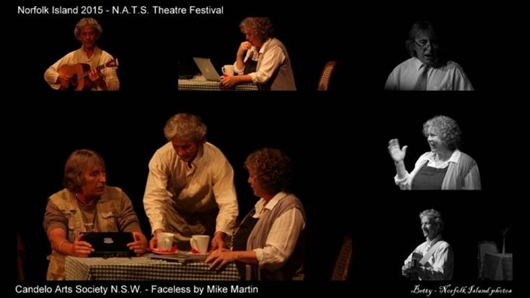

DIRECTOR DAVID STOCKER SAYS
Four of us from the Bega Valley under the auspices of Candelo Arts Society, took the play Faceless to Norfolk Island, a mere two hour plane flight from Sydney in the middle of the vast Pacific Ocean (well, not quite the middle but it was surrounded by water). The inspiration behind all this was Mike Martin, musician and raconteur from Candelo, who wrote the play and all the songs and acted in it. The rest of the Faceless crew were Mahamati (Theatre Onset) and Marty Lyons from Candelo with David Stocker (Theatre Onset) directing. The Theatre Festival is run every year with plays from New Zealand, Norfolk Island and Australia run over three nights. Plays had to be between 20-50 minutes with two or more actors. We saw giants on ladders and masks on school girls. We saw a true story of a coalminer in the dark and the odd affair of a female Aussie assassin (performed by one of the New Zealand groups). There was a most remarkable group of school children (equivalent of Year 11 & 12) from New Zealand who were amazingly well rehearsed and whose performances were inventive, creative and awesome. And we saw a group of octogenarians performing "Hutt River Has Talent". Inspirational in a lot of ways. It was an enjoyable week, both the Festival and staying on the island and I can recommend the event. If you decide to take a play over, or just visit, get a paw paw right away and eat it, try the meat, talk to the locals, visit the beaches, the ruins and the Cyclorama and go walking in the hills.
NOr FOLKING AROUND
a past theatre onset president and our current secretary help to finally bring some action to the Pacific

